MOUNTAINS OF THE MOON UNIVERSITY
FACULTY OF SCIENCE, INNOVATION AND TECHNOLOGY.
DEPARTMENT OF COMPUTER SCIENCE.
FUNDAMENTALS OF WEBSITE DEVELOPMENT
INDIVIDUAL ASIGNMEMT.

STUDENT’S NAME: KARAMAGI HENRY ATUHAIRE
REG NUMBER: 2023/U/MMU/BCS/00523
COURSE CODE: BIT 1204
YEAR: ONE
SEMESTER: TWO
LECTURER’S NAME: MR. MWANJE DERRECK
DATE OF SUBMISSION 22/01/2024

QUESTIONS
As a Web site Developer student, critically analyze at least six different websites for the
following categories;
✓ ECommerce
✓ Universities
✓ Hospitals
✓ URA
✓ Government Ministries
✓ NGOs
✓ IT Companies
Required:
1. Document the domain for each of the above selected websites.
2. Capture screen shots of the home pages containing the main Menu for each of the selected entity or category above.
3. Evaluate, critique and document the color choices for each of the selected websites.
4. Document the similar controls and components cutting across the above websites.
5. Generally, Critique the above selected websites, citing the loopholes, setbacks.
6. Identify and document the visible security features from the above websites
7. Basing on the critiques report, in your opinion Suggest ways in which the above websites could be improved.

Answers
- (a) Website domains
Ecommerce: jumia.com
Universities: mak.ac.ug
Hospitals: mulagohospital.go.ug
URA: ura.go.ug
Government Ministries: health.go.ug
NGOs: actionaid.org
IT Companies: ibm.com

- Screenshots
- Jumia.com
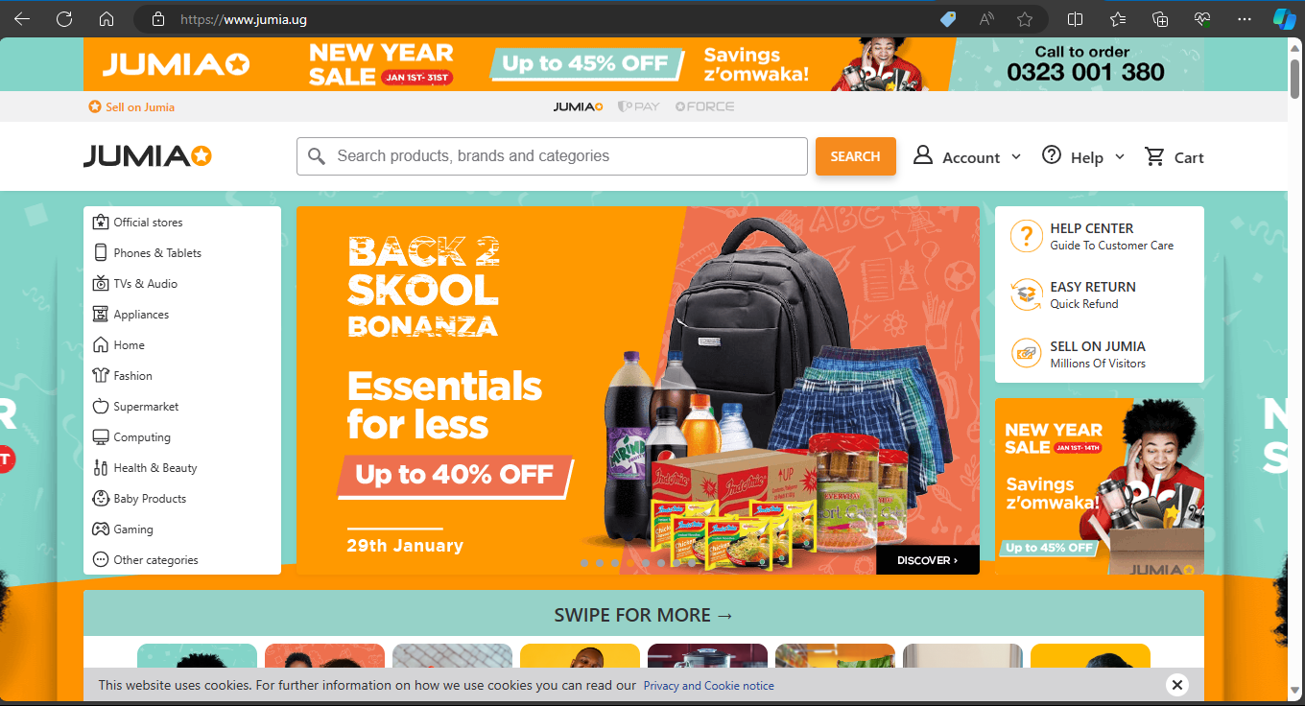

- Makerere university
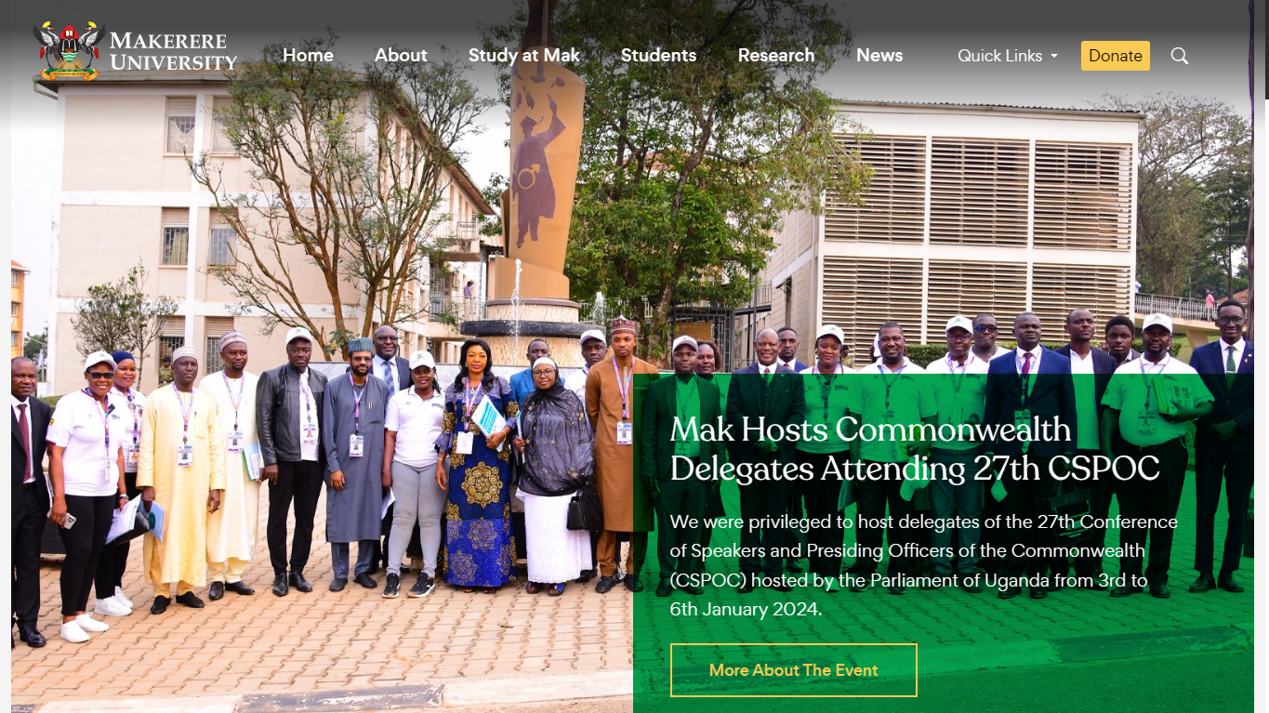

- Mulago hospital
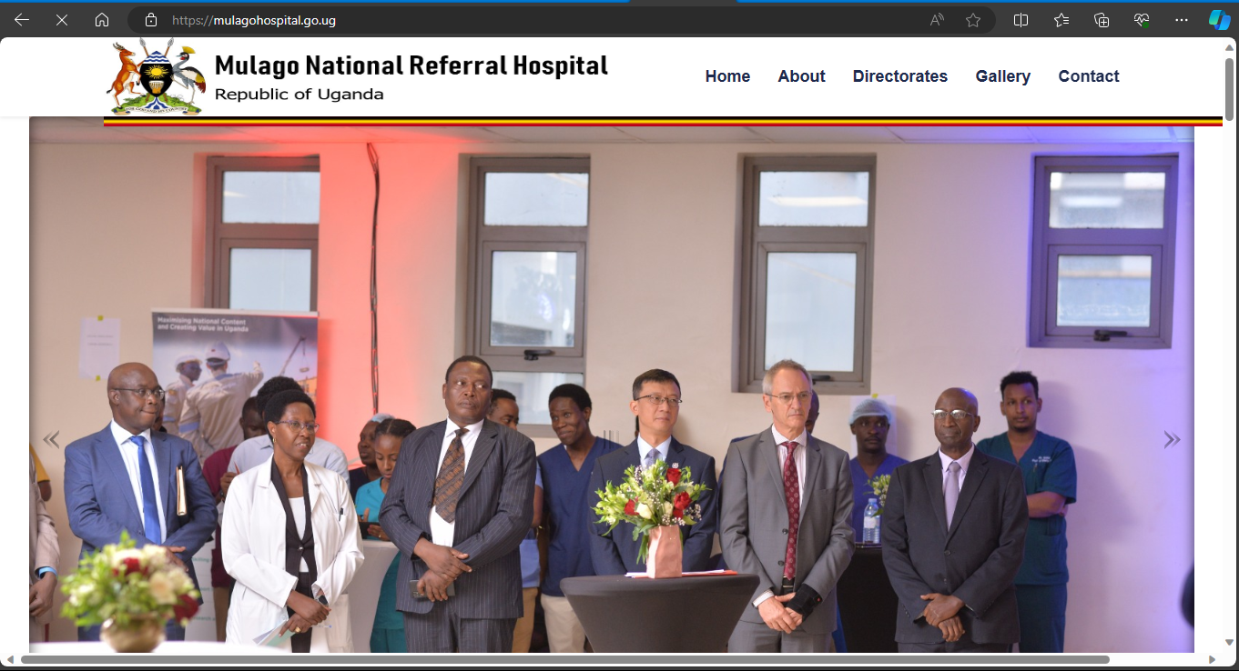

- Uganda Revenue Authority
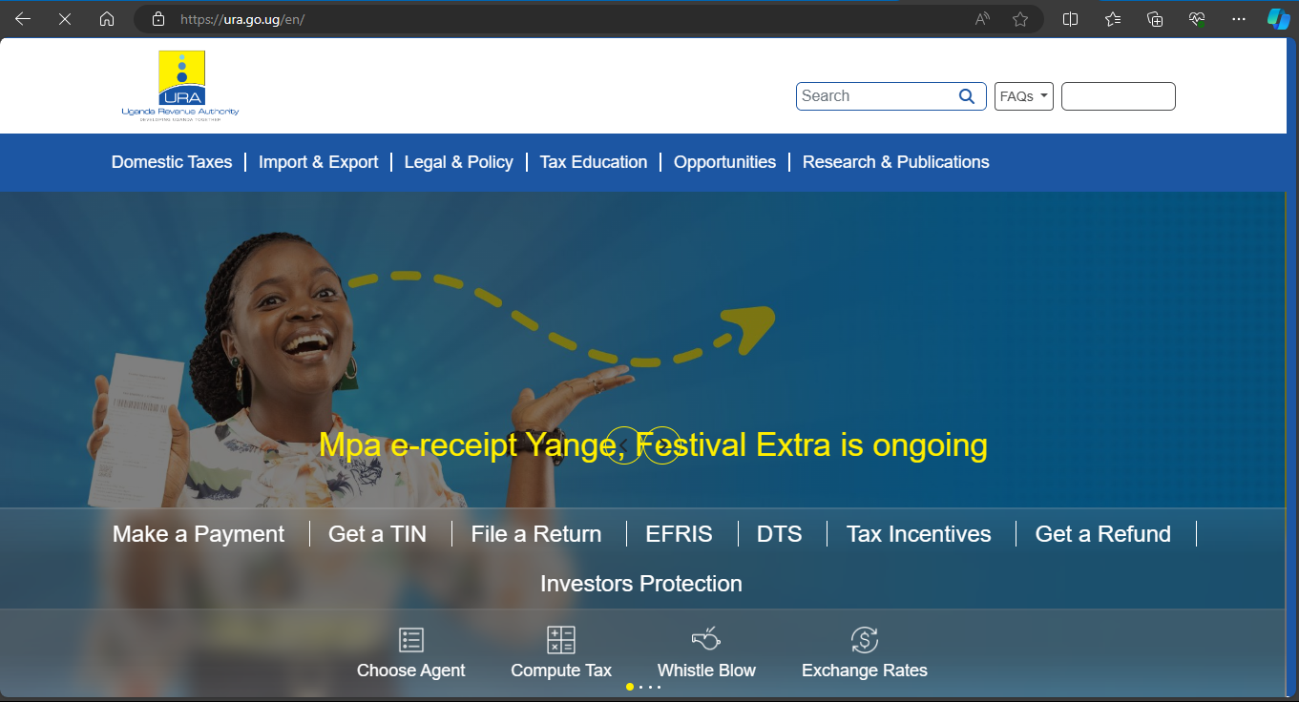

- Ministry of Health
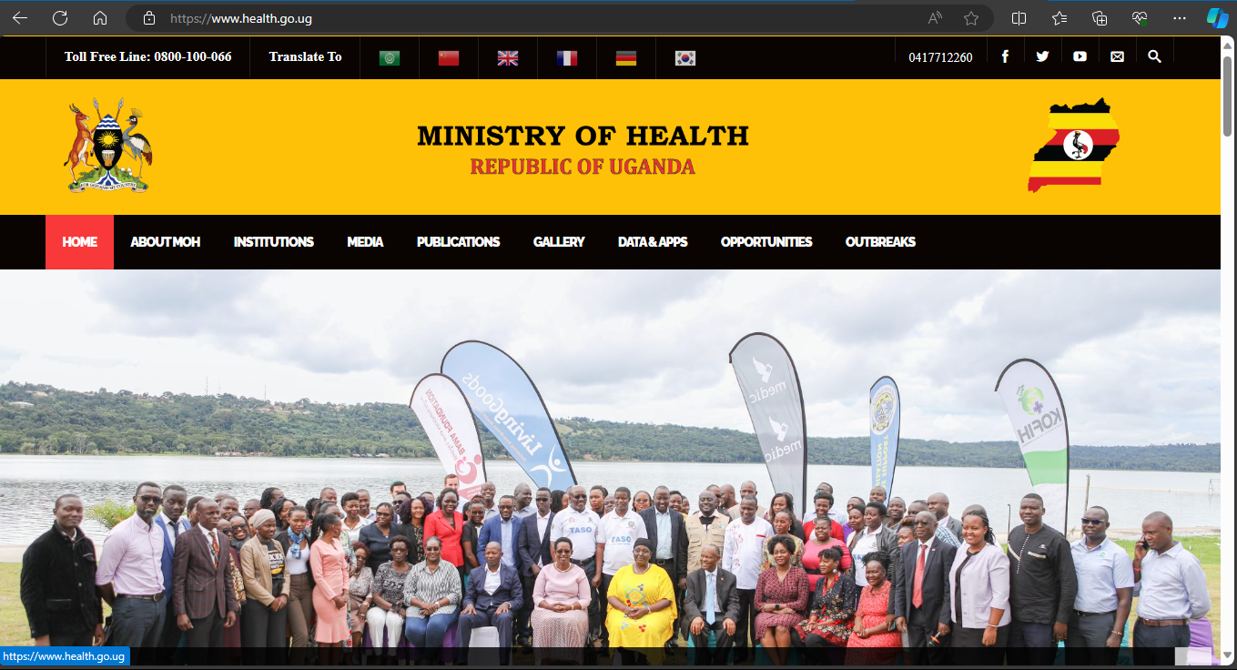

- Action Aid
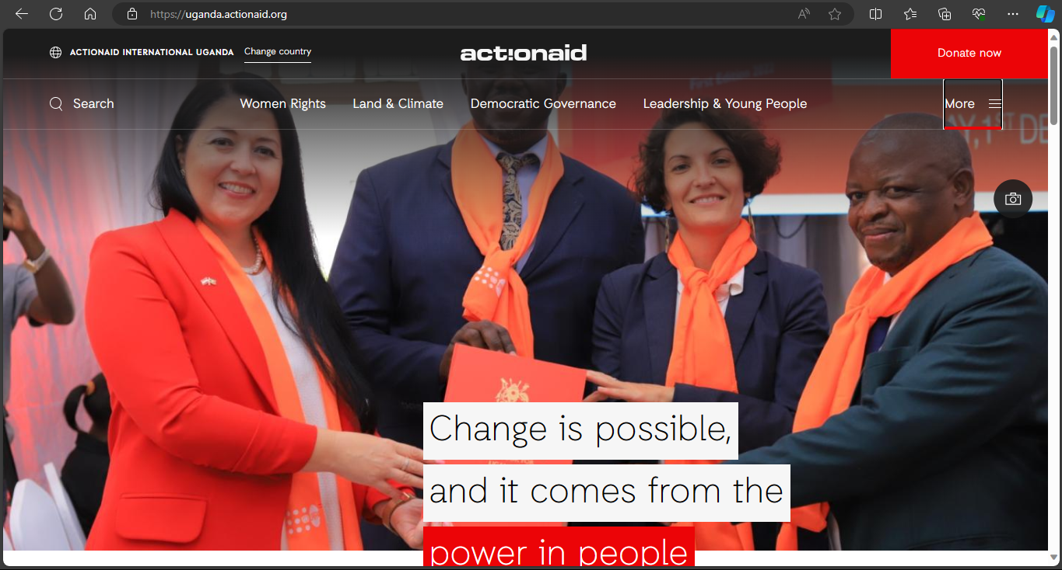

- Documentation of color choices
- Jumia.com
- Visibility: the color choices of jumia.com make their products more visible to the customers. For example, colors like orange around the hero section, blue in the back-ground sliders.
- Readability: Colors such as white in the categories’ menu make the content readable by whoever visits the websites.

- Makerere university
- The transparent green color on the home page does not cover the group photo in the background.
- The color also makes the words easily readable by the students and those who visit the website. This makes it easy for anyone to navigate through the website without any eye strains.

- Mulago Hospital
- The white background color in the home page makes the website so bright so it may not cater for those with eye defects.
- The color also makes the words readable and the pictures visible

- Uganda Revenue Authority
- The blue color in the background on the home page matches with the URA logo
- The yellow color in the picture also matches with the colors on the logo of URA
- The themes are transparent making the content of the website both readable and visible to whoever visits the website

- Ministry of Health
- The website uses multiple colors (black, yellow and red) that appear on the Uganda National Flag

- Action Aid
- The orange color used in the website matches with the organization theme of orange scarves and coats as shown in the background image on the home page

- Controls and components
- Controls
Buttons
Menus
Search areas
links

- Components
Logos of the specific organizations
Detailed footers of the organization information
Forms and input fields

- Loopholes and setbacks
- The jumia website is too congested with a lot of content on a single page which makes navigation difficult
- The URA website lacks detailed information which makes the information on it limited
- The background image of the Ministry of Health website does not correspond with the health department because it is more of the tourism sector
- The action aid website is so brief in a way that someone may find difficulty in understanding what it is all about
- The Roke Telecom website has information overload involving repetition of words on the same page written up to three times for example “Roke at home” on the home page
- The Mulago hospital website has more of images than the actual information

- Visible security features
- Secure payment methods
- Jumia uses secure payment methods for example bank transfer and mobile money.
- URA also uses secure payment methods like the use of mobile money and also bank transfer.
- Action Aid also uses mobile money and bank transfers for donations.
- Privacy Policy
- All the above websites use cookies for session management
- All the websites use access control since they deal with various user accounts

- In my opinion, the following are the ways in which the websites could be improved
- Regular updates: Through content and information up-to-date for accuracy and relevance.
- Enhancing Accessibility: Through making sure that all information on the website is accessible when navigating the website
- Optimizing Performance: For websites like Makerere university that take some time to load, images and scripts have to be optimized to improve performance
- Implementing User Feedback: Through incorporating user feedback to address usability issues

